Propane Storage Standard Operating Procedures
The purpose of the propane storage procedure is to ensure the proper storage of propane cylinders according to the regulations set by OSHA and CGA (Compressed Gas Association).

Step 1: Propane Cylinder Hazards
Propane is a hazards flammable material that carries large amounts of explosive force because it is pressurized.
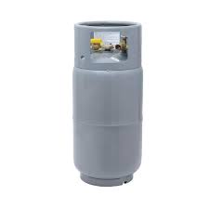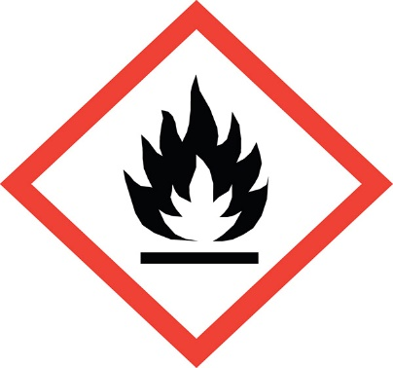

Step 2: Storage
All K&M Facilities will store propane cylinders outside to prevent the risk of fire or tank explosion inside the facility unless an exception is made by the Director of Safety and meet the local fire codes.
- OSHA specifies that propane cylinders cannot be stored near exits, stairways, entryways or close to high traffic and busy areas.
- Store propane cylinders outside and in an open-air storage unit at least 20 feet from other buildings and exit doors.
- Propane cylinders cannot be stored close to or with other flammable or combustible materials.
- K&M requires propane cylinders to be stored outside in safety cage, locked and on a flat area that does not collect water. Do not store in area of excessive heat (120 degrees or higher) or near a heat source.
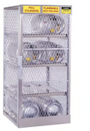
- All storage units should be horizontal storage units and will be provided by either the propane company or purchased by the Facilities department.

